UDC 681,327

HARDWARE AND SOFTWARE MODULE FOR UAV FOR QUICK ASSESSMENT MAPS AGRICULTURAL FIELDS

NV Bogdanov VV Ganchenko

*A hardware and software module for unmanned aerial vehicle (UAV) designed to adjust the card status of agricultural fields. The module allows you to perform a quick assessment of photographic images of the field along the route of the aircraft, form teams of the need to adjust the mapping and appropriate control signals for the UAV.*

Introduction

Precision agriculture is now gaining ground in many countries. precision agriculture technology examines every farm field as a non-uniform in relief, soil cover, agrochemical contents and involves the use of every part of the field of various agricultural technologies [1, 2]. The basis of the technology is state of the vegetation maps constructed by methods of remote sensing of the Earth from space, which require correction before the agro-technical measures. To adjust use the images produced by ground or aerial robotic systems for agricultural purposes.  
Existing UAVs of this type are characterized by low productivity data, the inability to store large amounts of data and the lack of stable communication with the base station. In this regard, the development presented in the report of the hardware and software modules for the rapid assessment of the state of vegetation is important.  
  
1. Description of module operation  
  
Hardware-software module is a single-board computer that is running the program, consisting of four main sub-programs (subsystems Figure 1.): Isolation of the test section, the comparison section and a reference, and correcting the position of the UAV formation data to be sent.

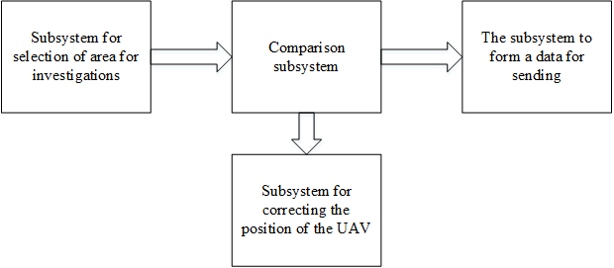

Fig. 1. Block diagram of the software module

The subsystem selection test site implements search and copy area for research. It highlights the border of the test images of certain patterns and separates it from the overall picture for further analysis. This module operation result is stored in the intermediate file for the convenience of the further work of the program.

Subsystem position correction UAV follows the patterns that are on the resulting image and compares them to those that need to go on a given route. In the case of the bias resulting coordinates are subtracted from those that must be drones. The result of this subtraction forms and sends a signal to the UAV control system.

Subsystem generate data to send extracts from the data that is stored on the memory card, the coordinate areas required for further study.

Comparison engine uses high-quality ratio, which is calculated according to the values ​​of the image in the HSV color space. This is done to reduce the impact of lighting conditions. Hue hue value is calculated as follows:

|  |  |
| --- | --- |
|  | (1) |

Sat and saturation - the formula

|  |  |
| --- | --- |
|  | (2) |

Hue Hue can range from -π / 2 to π / 2, and saturation Sat - from 0 to 255. In Table 1, the values ​​given Hue and Sat for various types of segments (on the hue and saturation values ​​of the data obtained on the basis of an expert analysis of the color characteristics images of individual plants and aerial potato field [3]).

Table 1

The color values ​​range

|  |  |  |
| --- | --- | --- |
| Type segment color saturation | Hue Range | Range Sat |
| Healthy (Green) | [0.1; π/2] | [110; 255] |
| The patient (Yellow) | [1.0; π/2] | [170; 255] |
| The patient (brown-green) | [1.0; π/2] | [128; 175] |

HSV space coordinate values ​​are calculated for each pixel. After determining the values ​​produced calculating the number of pixels of a healthy segment. Also considered to be the number of pixels that do not fall in any of the ranges. Of the total number of pixels subtracted the number of pixels that do not fall in any of the ranges. To calculate the quality factor of the ratio of number of pixels is taken from a healthy segment after the subtraction to the obtained number of pixels. In fact, this ratio characterizes the state of the agricultural sector.  
An important consideration in the design of hardware and software modules is the need for linking the single-board computer with on-board systems (Fig. 2). Therefore, in addition to the main program, described above, SBC operates a number of service routines that form the control signals for the data dispatch systems, photography, management, and others. In order to match the on-board voltage and voltage required to operate the hardware and software module requires a power adapter. Communication is carried out through established on most computers, single-board interfaces (USB, Ethernet) [4].

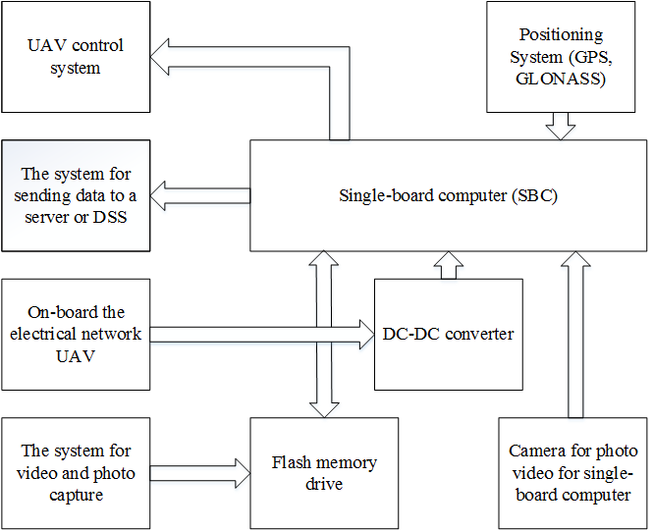

Fig. 2. Hardware representation of communication modules and systems BLPA

2. Algorithm work program of the system module program operation algorithm includes the following steps:

1. Held alignment of the white balance of the resulting image.

2. Searches in the resulting image area to explore. Reference sections for comparison formed in advance.

3. Found portion copied to memory devices. Just copied the file name

4. If the site is not, there is a quick search for patterns. In case of finding a pattern in a different area is calculated and the deviation signals are on BLPA control nodes. If you do not match any pattern, the signal is fed back to the base.

5. Calculate the quality factor of the site and compares the resulting ratio to a reference value for the quality factor of the site.

6. If there are significant deviations (decision boundary deviations set by the system operator depending on the type of vegetation, the vegetation period), the file name area data transferred to the sending system for processing a decision-making system. As for a possible ground processing coefficient stored in a separate array. The algorithm is repeated until the last file is read for comparison or until a command is received from the operator.

conclusion  
  
The work is developed the algorithm of the program module and its hardware scheme of interaction with the on-board equipment. The program carries out a rapid assessment and monitoring function of the state of vegetation, which reduces spending on agricultural activity by reducing the number of sites for a more thorough analysis. Just module software tracks the route of the aircraft and corrects it if necessary by management BLPA nodes. Using a single-board computer to simplify commissioning of equipment for specific tasks and allows you to extend the functionality as needed.

Bibliography  
  
1. Greenbelarus [electronic resource]. –

modeдоступа:http://greenbelarus.info/files/downloads/zashchita_rasteniy_v_organicheskom_selskom

_hozyaystve.pdf. - Access Date: 22.02.2016.

2. Nsu [electronic resource]. - Access

mode:http://www.nsu.ru/xmlui/bitstream/handle/nsu/318/03.pdf;jsessionid=F6A19137B3C6CC404E3C

F081A2FEDF8F?sequence=1#page=2&zoom=auto,-202,556. - Access Date: 02.09.2016.

3. Zastosowanie technik analizy obrazu do wczesnego wykrywania patogeno`w ziemniaka. Praca nie publicowana / B. Sobkowiak [et al.]. - Poznan`: PIMR, 2006.

4. SBC [electronic resource]. – Https://dl.dropboxusercontent.com/u/4035896/a320_downloads/SBC_comparison44.pdf Access. - Access Date: 20.03.2016.